**The Ark Documentation.**

**Study Details (for Existing Study Management).**

Log in and select your study by clicking the hyperlink corresponding to the name of your study.

Once you have chosen your study we will be able to adjust study details or select modules and functions available in that study (for which you have privileges).

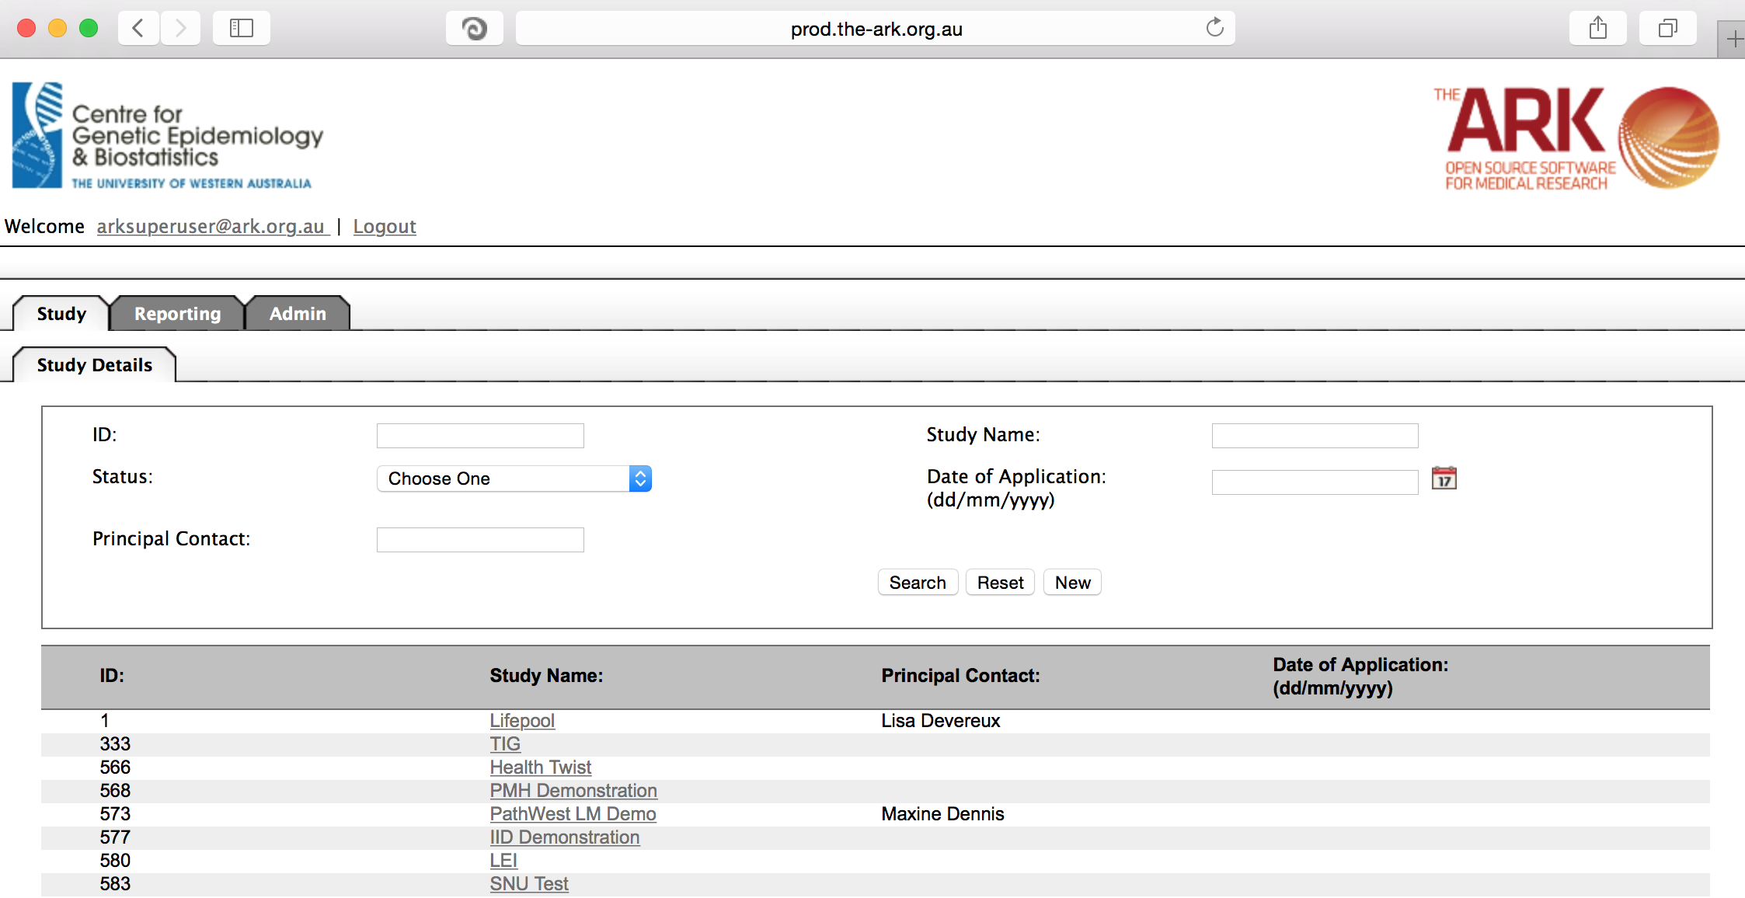

Alternatively if you have a very long list of studies under your management you may use the search pallette/panel at the top of the page. You can search/filter by id, name, principal contact, status of the study or date of application. Once you have added your filtering criteria, click the search button;

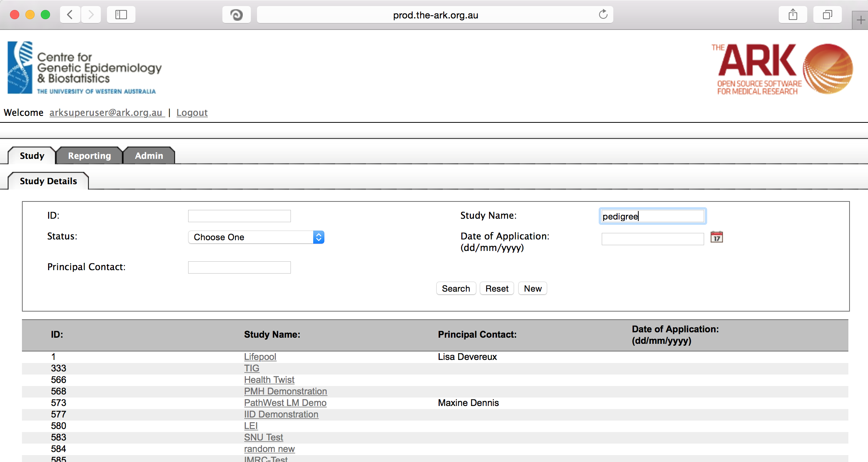

As you can see the filter has helped us find our chosen study and we can click the hyperlinked study name as discussed before;

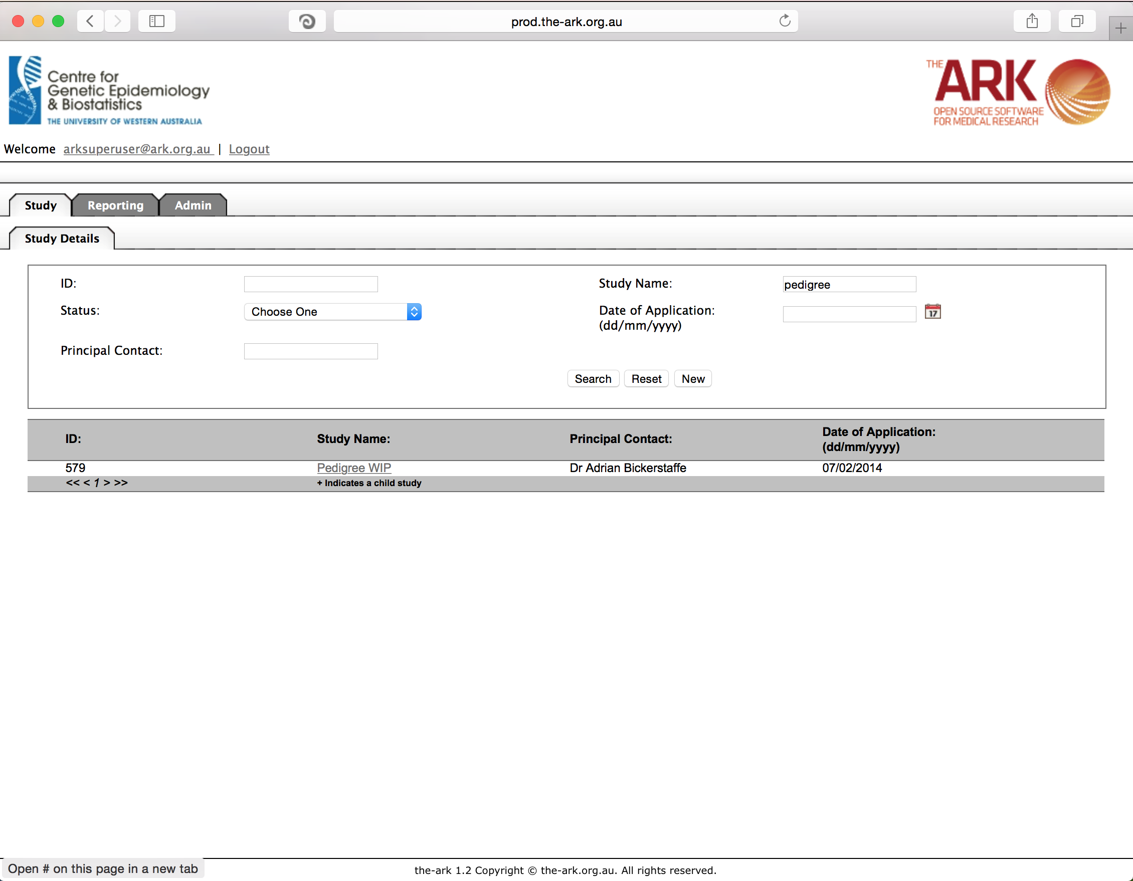

Once you have chosen your study we will be able to adjust study details or select modules and functions available in that study (for which you have privileges).

The fields are all self-explanatory and you are welcome to use them as you see fit but I will list the following dangerous fields that have consequences beyond just being information. You will only be able to edit these fields if you have study administrator privileges.

* Study Name. Once you have decided a study name you are best to stick to it. There are certain bugs in the code, which will be fixed in future releases, where there are adverse affects from changing names. Trust us; don’t change names for now please.
* The status drop down is critical, as select an archived status could hide your study from searches and require and SQL adjustment to make it visible again (in the future a function may be added to recover studies).
* Application modules. You will only be able to use those modules that are selected here.
* Auto-generation of subject UIDs, Biospecimen UIDs, Biocollection UIDs. Once you have made these choices and utilized them in create of subjects/biospecimens, you are stuck with those fields permanently. Carefully consider if you want these auto-generated or not. This functionality has been made to prevent issues with duplicate identifiers.

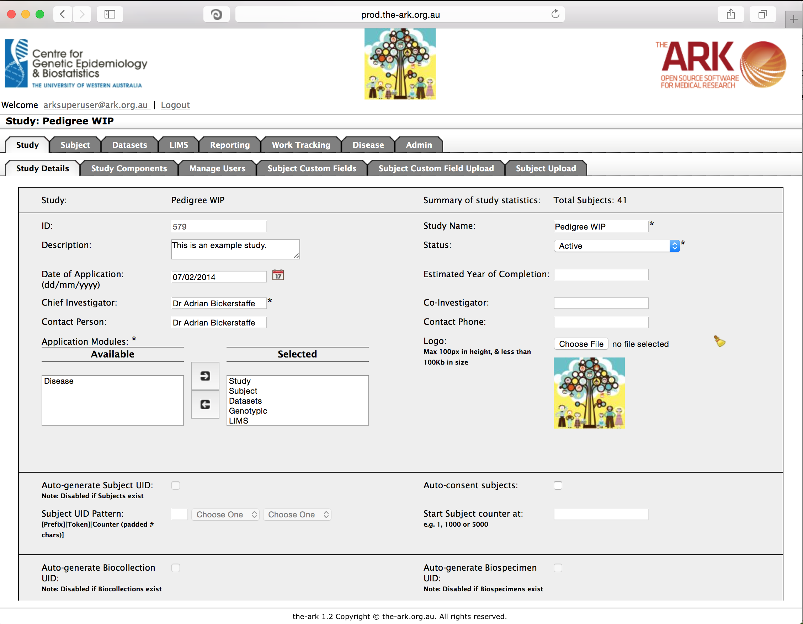

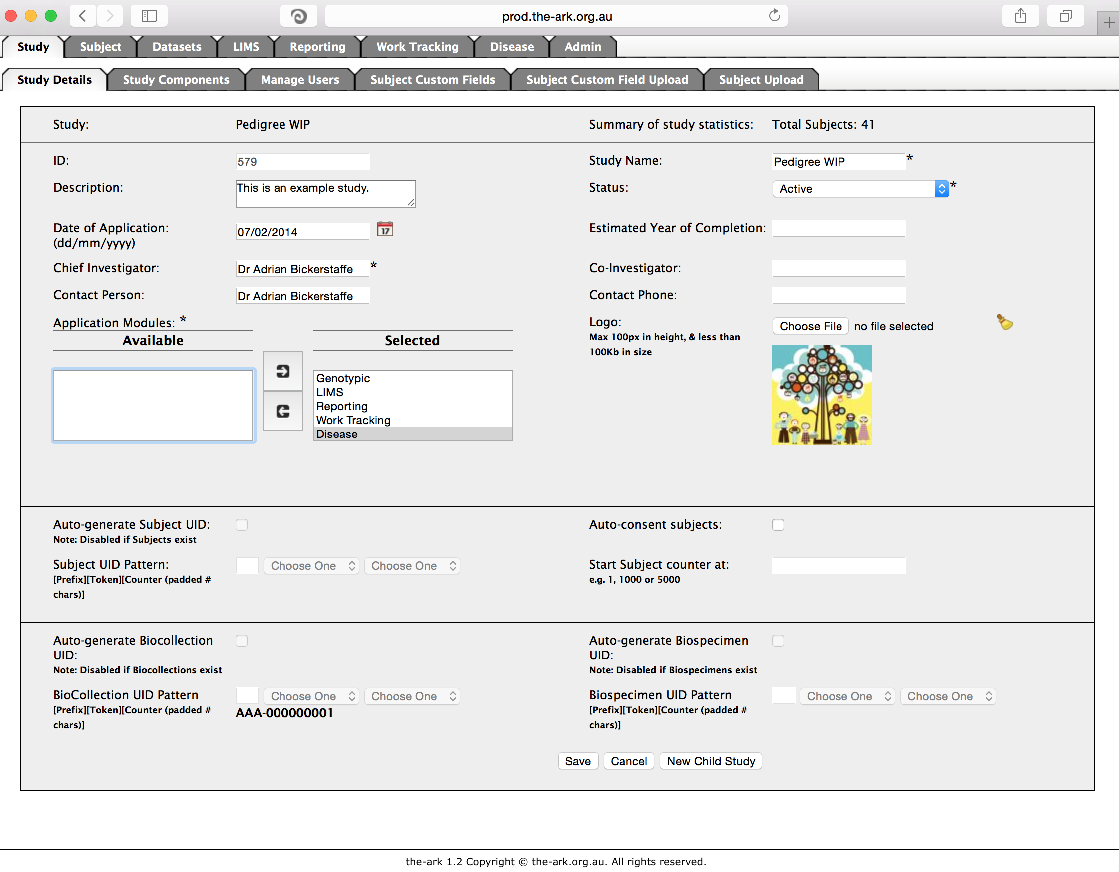I have shown above, an example of adding the Disease module to your available modules for your Ark users for this study. This is done by either double clicking the chosen module until it is where you want, or selecting and clicking the arrow button in the direction you want

Once you have made all of the changs you need, click the save button

If you have no issues and it has correctly saved, the you will have a green message at the top of the page telling you so. If there were any issues (rare on this page), a message will show up in red describing what you have done wrong.

